BEHAVIOUR MANAGEMENT
POLICY

Adopted | March 2019
Lead | LB SC
Reviewed

Introduction

This behaviour appendix adds detail to “The Harmony Trust Behaviour and Anti-Bullying Policy” which is adapted in full by Carlyle Infant and Nursery Academy.

Reference should be made to that policy in addition to the information in the appendix that follows.

When putting together this policy, reference has been made to the EEF Guidance Report released in July 2019, and other sources of research.

Our academy community relies on every member of the school feeling valued and respected. Every person needs to be treated fairly. These values are built on the important mutual trust and respect for all. We aim to promote an environment where everyone feels happy, safe and secure. This policy is therefore designed to support all stakeholders. This allows for effective learning to occur in classrooms and within a school with a positive and purposeful atmosphere.

It is accepted that effective learning and teaching requires a safe, calm and peaceful environment. Pupils need to have a clear idea of what is expected of them, not only in terms of academic achievement but also in social training. Pupils expect to be treated fairly and consistently and be positively encouraged to behave well. To help encourage positive behaviour, members of the school should have a clear understanding of their rights and responsibilities, and have clear guidelines for what acceptable behaviour includes. Appropriate support should be given when needed.
Underpinning this policy are our values and vision - ‘We are flying high!’

Rights
• to enjoy a safe and positive environment
• to have effort and achievement recognised and rewarded
• to be able to learn and teach without undue disruption
• to aim at a set of clear, realistic and challenging targets
• to recognise that all members of the school are individuals whose needs should be met

Responsibilities
• to attend school regularly
• to behave in an acceptable and appropriate manner
• to encourage positive social skills
• to work to maximum potential both academically and socially
• to take pride in one’s self and in producing work of the highest quality
• to help promote positive relationships between all members of the school and encourage an environment of mutual respect.

Minimum expectations

The orderly running of the school is premised on the following “minimum expectations” across the whole school community and site; these involve making ‘Wise Owl Choices’ (found in the Behaviour Booklet).

- Be Kind (kind words, hands and feet)
- Be Safe (keep themselves and others safe)
- Be Ready (ready to learn, listen, act)

At the start of each year, each class will discuss and agree what Ready, Kind, Safe means for their class using age appropriate language and concepts. These three statements have been agreed by all stakeholders and are closely linked to the British values of democracy, the rule of law, individual liberty and mutual respect for, and tolerance of, those with different faiths and beliefs and for those without faith.

If children follow these expectations, they can gain rewards. If pupils do not follow these expectations, there are consequences set out in this policy.

The aim of all consequences is twofold;
- To help pupils moderate their behaviour
- To ensure the orderly running of the school

At Carlyle Infant and Nursery Academy, we deal with all behaviour consistently in order to create the firm boundaries children need in order to feel safe, thrive and learn. Each adult has a responsibility to conduct themselves in a positive and engaging manner.
- We celebrate when our children are following the expectations
- We use a calm, assertive approach when responding to children who have not acted in line with the minimum expectations
- We model good behaviour at all times.
- We have the highest expectations of behaviour in our school from staff, pupils, parents/carers and visitors.
- We understand that some children will need additional support to follow the expectations and that all children will learn at different rates.
- We focus on positive behaviour (catch them being good).
- We have an agreed hierarchy of consequences to guide our responses to a child’s behaviour. Rewards are incremental but are at a teacher’s discretion.
- We involve parents/carers in the rewards and consequences for a child’s behaviour.
- We use our professional judgement, knowledge of the child and advice from outside agencies when applying consequences for wrong choices.
- We always use the smallest consequence necessary to help the child learn.
- We apply consequences consistently and fairly.
- We give children the opportunity to reflect on their choices and make changes if necessary.

Praise & Rewards

We promote an ethos where children’s learning is a reward in itself so the children are not only driven by external praise. However, there are times we would like to celebrate their successes, therefore we use many reward strategies in school, for example:

- Smile – the most common reward is to recognise that the child is making the right choices.
- Verbal praise – public recognition for correct behaviour choices/or good work.
- Written feedback in books – comments made for super work and effort.
- Stickers - these may be distributed either for good work or behaviour.
- Good work can be shown to the class, another class, another adult in school or copied to send home
- Collective whole class rewards, for example ‘marbles in a jar’ or stickers for a chart for positive behaviour, hard work or meeting class targets. A full jar or a chart leads to a whole class treat or special time as agreed between the teacher and the children. This is at the discretion of the teacher.
- Visual reminders around school
- Learner of the week- OWL assembly sharing success with peers
- Postcard home to parents in the post to share positive news stories or work success.
- Nomination for afternoon tea once each half term with member of SLT in recognition of those who uphold high expectations and are a positive role model/working to best of ability.

Dojo individual points
Each class will have an electronic copy of the Dojo system. Each Monday it will be reset to 0 and children will be rewarded dojos for following the academy expected behaviour and producing good work. At the end of each week the child with the most Dojos in the class will receive a sticker to wear with pride and take home to show their family.

Dojo Team Points
Children are grouped into four Dojo Teams. These are Squirrels, Foxes, Badgers and Hedgehogs.
Each child is placed in a team on entry to academy and remains a member of this team throughout their time at the academy. Siblings are placed in the same House team. Team captains are chosen from Year 2. Members of teaching and non-teaching staff are also placed into a team to show encouragement and praise as well as a sense of belonging and unity.

Dojo Team points can be awarded by all staff to children following the academy vision and for demonstrating positive attitudes towards work and teamwork. Points will be recorded on class dojo.

Every week, the team points are counted by our team captains and a weekly winner announced during our Celebration Assembly every Friday and added to the Dojo Team Point chart on display in the corridor. Team points are then tallied over the course of a term, a winner is announced, and the children in that team are rewarded with a special treat as part of their reward afternoon.

It fosters community spirit and gives the children an opportunity to contribute to something bigger, which involves children from all year groups. The older children are positive role models and take on a pastoral role for the younger children.

Consequence for poor behaviour

We have a ‘No Shouting’ expectation across school, we expect adults to talk to children calmly about their behaviour and vice versa. Dealing with disruptive and rule breaking behaviour is a graduated approach, from the least to the most intrusive.

Even though it is acknowledged that warning and consequences are needed, they are to be used selectively. Teachers must liberally build relationships with pupils & give praise, encouragement, incentives & celebrations. In particular, use of the 5:1 ratio for praise and warning/telling off is necessary.
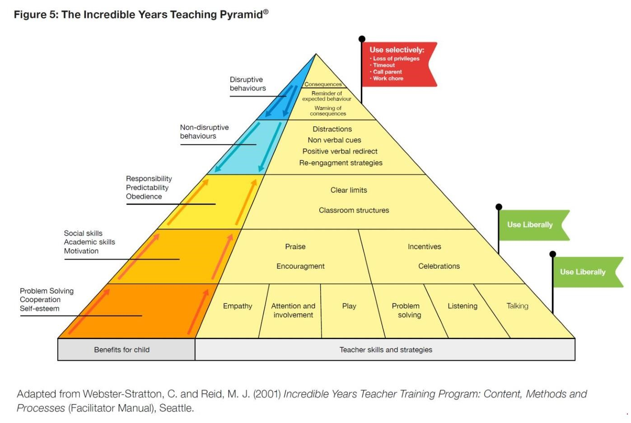

Every child will start their day on a positive. The Dojo chart will be shared and children will be reminded of ways to achieve Dojo points. This will encourage the children to make wise choices and allows the expected behaviours to be regularly shared with children.

Throughout the course of the day, if a child is displaying signs of frustration, anger or disruptive behaviour- staff will follow the lower tier strategies to help identify the root cause of the behaviour and build relationships with the child. We are firm believers that behaviour is a form or communication and through strong relationships and communication it can often be restored.

All children deserve a chance to explain themselves; it is the adults’ responsibility to allow time for this as close to the incident as possible to make sure it is dealt with fairly. If it is not possible to talk to the child straight away the child should have chance to record what happened either through pictures or writing it down.

Stage | Behaviour | Action
Praise and encouragement | Initial signs of low-level disruption. | Praise the child for any choices that they are making that are the right ones (eg thank you for sitting on your bottom on the carpet even if they are shouting out whilst there) and use positive language to peers around them. Reward others with Dojos and set the example.  At an appropriate time, check-in/talk with the child in private.
Verbal  Warnings x2 | Low level disruption. | Remind the child of ‘expected behaviour’. This should be done discreetly/in private where possible. “At Carlyle we expect you to…”
Cool off time in class | Continuation of low-level disruption or more serious first-time offence. | Time out in reflection corner/zone/table in class for 5 minutes. Restorative conversation with all involved must follow this before they are brought back within the class.
Cool off time in partner class | Continuation of low-level disruption (despite class reflection time) or more serious first-time offence. | Pupil sent with orange card (with reason for card written on the back) to partner class and spend 10 minutes in the class reflecting on their behaviour.  Where possible, the partner teacher/ta should talk to the child and help them to reflect effectively on their choices and the reasons behind them.  At the end, the partner teacher will sign the card and the pupil will return to normal class and be welcomed back by class teacher.
SLT support | High-level first-time disruption.  Refusal to leave for partner class when requested.  Continuation of low-level disruption (upon return from partner class). | Sent to Head of Academy/DHT with red card (reason on the back) to remain with them for the rest of the session. SLT will keep a record of these incidents and follow the steps below.  Always recorded on CPOMs by class teacher  1st red card – teacher has end of day conversation with parent (be sure to give them the option of coming into the classroom to talk in private)  2nd red card – another conversation with parent with the SENCo also present to offer any support/ address any issues.  3rd card – conversation with SLT and teacher  4th card – Advice will be sought from behaviour support or referral made to the SENDCO for Educational Psychology input if necessary.
Exclusion or exclusion | Serious physical or verbal assault.  Continuous defiance/ low level disruption | In line with the Trust policy, The Principal reserves the right to use temporary and permanent exclusion.  To be recorded as per Trust and  Local Authority guidance

Teachers may use other strategies that are reasonable and proportionate to any behaviour incidents. This may include but is not limited to

- Keeping pupils in at break/lunchtime to finish work
- Moving a pupils space in the classroom
- Asking another adult in school to speak to the child

SLT may also use other strategies that are reasonable and proportionate to any behaviour incidents. This may include but is not limited to
- Seclusion at lunchtime
- Internal seclusion (for 0.5 days or longer)

Break and lunch time Behaviour
Promoting a Positive Playground Community
Systems to support Positive Behaviour and Wellbeing in the Playground:

1. A variety of playground activities and equipment are to be made available to the children
2. Use of library will be available for those students wishing to engage in reading, research and indoor games
3. Supervised sports and activities are to take place regularly
4. Children are to sit for a minimum of ten minutes when eating at breaks.
5. Staff are on duty, on time and are to actively patrol their designated area. Duty teachers are to wear fluorescent jackets for visibility and carry epi-pen and first aid bags.

The school guidelines, rewards and consequences will apply during lunch time. The supervision of the children at lunch time will be the responsibility of the senior lunchtime supervisor, along with a team of lunchtime teachers. Clear and effective communication between staff on duty at lunch time and other staff is essential. Any child who consistently chooses to behave in an unacceptable manner will be reported to Class teacher, the Key Stage Leader or Principal by the Senior Lunchtime Supervisor after consultation with other Middays. Children will be supervised at all times. The staff on duty at lunch time will provide appropriate activities for the children.

The children are reminded that the standards we expect in the classrooms are also expected outside.

1st step – child will be sent to the cooling area for 5 minutes.

2nd step – if poor behaviour continues at playtime then the child will be referred to a member of SLT. The SLT reserve the right to use all reasonable and appropriate consequences in order to stop poor behaviour this includes but is not limited to

- Breaktime ‘time out’
- Lunchtime ‘time out’
- Break time behaviour plans

Depending on the severity, behaviour at these times may need to be recorded on CPOMs. If unsure, consult a member of SLT.

Pupils with persistent behaviour problems
Where pupils are persistently or seriously breaching the minimum expectations, the academy’s response will be as follows
- Children who display consistent behavioural problems will have a behaviour wellbeing plan and a contract. This is a plan that will involve all adults who work with the child, SLT, parents and the child themselves. The purpose of the plan is to change the child’s behaviour.
- Each plan will identify key adults who can help that child – especially when they are experiencing a behavioural crisis.
- Whenever there is a serious incident for a child on a plan, the incident will be reviewed to ensure the plan has been followed.
The plan will then be reviewed to see if it needs to be changed.
Whilst we endeavour to help all pupils to meet out minimum expectations, where plans are not working and efforts have been exhausted the school, in line with Trust policy, reserves the right to use temporary and permanent exclusion.

Supporting all Children
Children with Special Educational Needs, pupils at risk and vulnerable children are supported in our Behaviour Policy in the following ways:

- Inclusion Manager and Teaching Assistants to support additional needs within and outside of the classroom.
- Rewards and sanctions are visual and auditory to ensure access to all.
- Individual reward systems can be adapted and created to support individual needs.
- Use of regularly reviewed behaviour plans

Monitoring, evaluation and review arrangements

The senior leadership team will monitor the implementation of the policy. It is expected that all staff will fully implement the policy at all times in school, striving for consistency and continually aiming for increasingly high standards of behaviour throughout school. The policy will be evaluated and necessary changes made to either the written policy, or the practice in school. This policy will be reviewed annually.

Behaviour and Wellbeing Plan

Pupil Name Class Year Group
Observed Behaviour | Triggers
Behaviour Targets:

Short term targets:
1.
2.
3.
Reviewed
Next review due:
Methods and Resources to meet target:

Success Criteria:

Rewards: | Sanctions:
Action and By When

Orange card for time out in partner class Red card for time out with SLT

Please stop what you were doing and think about your choices.

Please stop what you were doing and think about your choices.

Bring this card back to me in 5 minutes and talk to me about how we can help you behave in the expected way.

Postcard home to celebrate success
A message home to let you know that your child has been
‘OWLTASTIC’
at school

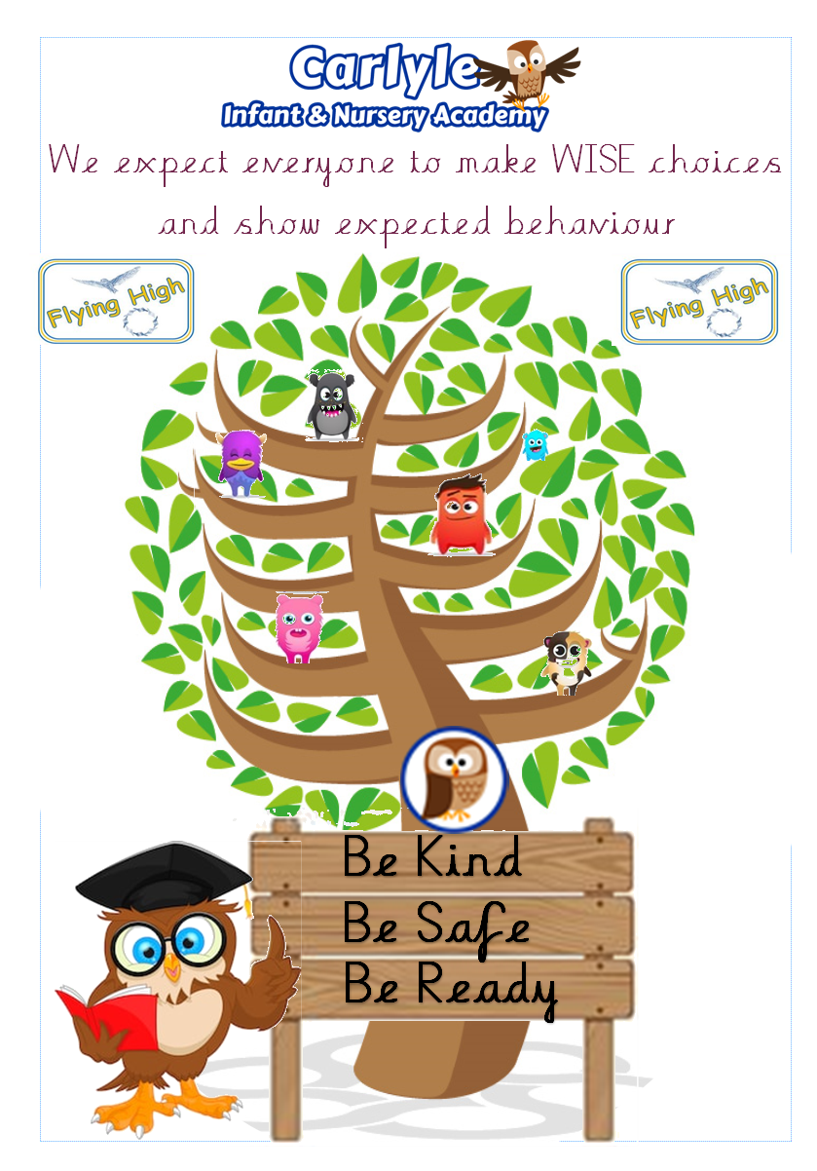

Behaviour expectation booklet

Reflection sheets for Time Out

Stickers for weekly class Dojo winners:
