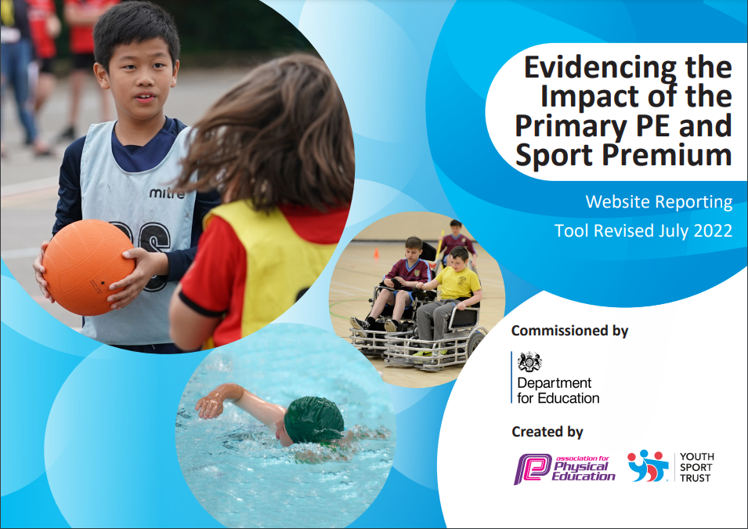
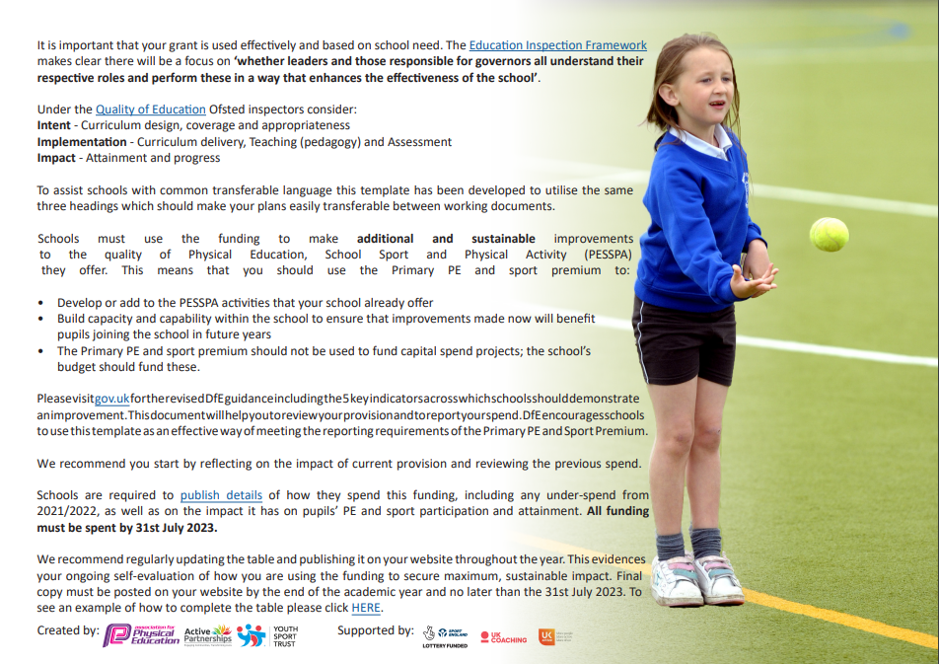
Carlyle Infant and Nursery Academy
Academic Year 2022-23
Rationale

At Carlyle Infant and Nursery Academy we aim to build on children’s natural enthusiasm for physical exploration by providing stimulating, purposeful and challenging experiences through games, dance, gymnastics, swimming, athletics, the daily mile and outdoor and adventurous activities. We aim for as many pupils as possible to engage in activities that promote their physical development including being involved in competitive sports.
We know from evidence that physically active children are not only healthier but do better academically and in life; they are far more likely to be active as adults. The first ten years of life provide children with a blueprint for their adult lives and is the time when they develop the critical fundamental movement skills that act as foundations and building blocks for future activity.

Summary of Proposed activity for 2022-23
- Children will work with Cycle Derby to develop their balance and gross motor skills.
- KS1 playground and Cycle area/Sensory Garden will be adapted to provide a range of physical activities that enhance pupil’s physical and social skills, cognitive development, fine and gross motor skills and mental health and wellbeing.
- EYFS outdoor area will include a range of thematic learning opportunities that enable children to develop fine/gross motor skills.
- The profile of sport will be raised across the academy through increased enrichment opportunities for the children linked to sports and activities.
- Increased communication with parents regarding sporting achievements, healthy eating and pupil’s mental and physical wellbeing.
- An effective PE curriculum that is taught with confidence across the academy with clear progression of skills from EYFS through to year 2.
- Continued partnership with Premier Sports: Lunch time active club, after school clubs, enrichment opportunities, competitive sports and skills.

Intended Impact of the Pupil Premium / Sports Funding

It is intended that the above actions will be sustainable over time as they focus on:

- the engagement of all pupils in regular physical activity

- raising the profile of PE and sport across the school as a tool for whole-school improvement

- increased confidence, knowledge, and skills of all staff in teaching PE and sport

- broader experience of a range of sports and activities offered to all pupils

- increased participation in competitive sport

Review of our previous strategy

Key achievements to date: | Areas for further improvement and baseline evidence of need:
The engagement of all pupils in regular physical activity  . Premier Sports (outside sports specialists) worked with all children weekly – games, gymnastics and dance, physical literacy, fundamentals.  Feedback from children includes –  ‘I like to play football and dodgeball with Premier Sports’  ‘Sometimes in gymnastics we have the equipment out and we need to control our bodies’  ‘It’s fun in PE because we play team games’  ‘We show our routines to the rest of the class’  ‘It’s important to exercise so that we can be healthy’  -Cycle Derby worked with all children from EYFS. Helped develop independence and resilience skills.  The profile of PE and sport is raised across the school as a tool for whole-school improvement  . Premier Sports BLM - Children’s speed and endurance assessed termly over the course of the year and monitored for progress. Teachers were able to monitor improvement and use as a tool for PE, encouraging growth mind-set and a desire to improve.  Increased confidence, knowledge and skills of all staff in teaching PE and sport  -Teacher/TA CPD throughout the year games, gymnastics and dance, physical literacy, fundamentals. In response to teacher audit of needs).  Broader experience of a range of sports and activities offered to all pupils  All children worked with Cycle Derby – 80% increase in the number of children riding a pedal bike.  Purchased pedal bikes and helmets in preparation for the new cycle area for next year.  Lunch time sports provision offered daily to pupils by outside agencies.  Increased participation in competitive sport  First School Sports Day in the last three years – with parents onsite and supporting.  - - Intra-sport games and competitions tool place over summer – all children took part. | The engagement of all pupils in regular physical activity  . Continue to increase physical activity each day through active brain breaks/daily mile/trim trail etc.  . Continue to promote the use of the Daily Mile for all children  Increase KS1 weekly PE lessons.  Develop outdoor physical activity opportunities for KS1 including the use of the new cycle area/sensory garden.  Increased PE and physical activity opportunities used as whole school rewards.  The profile of PE and sport is raised across the school as a tool for whole-school improvement  . Promote sporting achievement and clubs through website, Dojo and school newsletter.  . Staff questionnaires – gather feedback to support accountability and impact and future targets linked to spending.  . Increased staff CPD for ECTs with a focus on planning for progression  . Improve playtime and outdoor behaviour with a range of sports and structured physical activities - look into training for middays.  . Achieve Healthy Schools Status working alongside PSHE lead.  . Termly BLM – Premier Sports - to assess children’s stamina and fitness levels (increased use of Daily Mile should lead to positive impact).  Create outdoor learning areas to facilitate physical activity through cross curricular links  . Focus on incorporating physical activity in the classroom – cross curricular links  Re-introduce afterschool sports clubs lead by outside agencies and school staff.  Increased confidence, knowledge and skills of all staff in teaching PE and sport  Use Focus Ed (PE) as a tool to support the development of the whole school curriculum ensuring staff are confident with the NC expectations for PE and how skills progress over time.  Update new LTP with PE progression in skills and knowledge from EYFS to KS1.  Audit staff needs – arrange appropriate CPD particularly for those new to year group/ECTs.  TA trained to lead Physical Literacy across the school (carried over from 2021-22).  Broader experience of a range of sports and activities offered to all pupils  Audit EYFS outdoor provision to enhance and support physical activity outdoors.  . Liaise with outside agencies to organize inter and intra school competitions.  . Increase opportunities for pupils to develop cycling as a life-long skills – working with the support of Cycle Derby)  Develop outdoor cycle area/sensory for children to use.  Create playtime zones lead by mini leaders.  Focus on how PE and physical activity can be used to enhance cultural capital.  Set up school dojo groups to be used during competitive games and sports across the school.

Action Plan and Budget Tracking
Capture your intended annual spend against the 5 key indicators. Clarify the success criteria and evidence of impact that you intend to measure to evaluate for students today and for the future.

Academic Year: 2022/2023 |  | Total fund allocated: £17,180 |  | Date Updated: 30th June 2023
Key indicator 1: The engagement of all pupils in regular physical activity – Chief Medical Officer guidelines recommend that primary school children undertake at least 30 minutes of physical activity a day in school
School focus with clarity on intended impact on pupils: | Actions to achieve: |  | Funding allocated: | Evidence and impact: | Sustainability and suggested next steps:
 |  |  |  |  | % of total allocation: 81%
Encourage children to be active by integrating physical active into every aspect of life. | Develop outdoor movement and sensory garden |  | £5000 | Inspire, motivate and engage pupils whilst increasing levels of physical activity.  Help create cross curricular links.  Contribute to the recommended 30minutes a day physical activity children should undertake. (PE Lead to monitor).  Help improve behaviour and concentration levels.  Encourage resilience (Staff feedback). (Observations/staff assessments)  Promote good behaviour for learning.  Increase enjoyment of physical activity | Monitor the impact and daily usage of the area.  How effective is it? What could be done to increase engagement?  Look at opportunities to extend outdoor provision further, look into outdoor providers such as Active Learn.
Create opportunities for children to develop a skill, which will increase their activity levels and give them an enjoyment for being active. | Book Cycle Derby sessions in 6-week blocks for each class – continued from last year |  | Cycle Derby £1800 | Pupils will have learnt a new skill – continued from last year (Assessment matrix).  Increase/encourages physical activity in and out of school. (Parent feedback, pupil certificates)  Year 1/2 – all riding independently  Most of FS2 riding pedal bikes independently  Nursery – mostly using balance bikes, core strength improving. | Monitor impact of lessons – what percentage are riding pedal bikes/ how can we increase this further? Focus on development of school cycle area/sensory garden.  Train staff to support children on bikes.
Introduce new Mini-Leaders to support and lead arrange of games and activities during outdoor social time. | Arrange training with Premier Sports  Support Midday Supervisors to ensure lunchtimes can be more active.  Purchase equipment for use during break and lunchtime. |  | £150 | Lunchtime and break time is more active for pupils, contributing to 30 daily active minutes (observation/ feedback from staff/discussion with children). | Develop Mini Leaders Award for pupils to lead some mini playground games.  Will form part of the updated behavior plan
Continue to Increase fitness levels of pupils and enjoyment of outdoor sport and physical activity. | Organise daily lunchtime sports activities for all pupils to access – Premier Sports  Organise afterschool clubs available to all children through the year through the use of external agencies and delivered by class teachers. |  | £7000 | Contributes to the recommended 30minutes a day physical activity children should undertake. (PE Lead to monitor).  Increased fitness levels (data)  All pupils exposed to a range of sports, learn new skills and games both competitive and non-competitive. | Continue to work with Premier sports.  Continue to monitor the impact and effectiveness.  Look at introducing intra-sport games across school.
Key indicator 2: The profile of PE and sport being raised across the school as a tool for whole school improvement
School focus with clarity on intended impact on pupils: | Actions to achieve: | Funding allocated: | Evidence and impact: | Sustainability and suggested next steps:
 |  |  |  | % of total allocation: 4%
School newsletter to include news re participation in sports events, competitions and festivals, encouraging pupils to take part and informing parents of whole school commitment to PE and Sport. | Look at ways to gather information regarding sporting achievements/clubs children attend. | n/a | Pupils inspired and motivated to take part in sporting activities (registers, feedback).  Parents are proud of their children’s participation in events (feedback).  Increase in self-esteem/ confidence is having an impact on learning across the curriculum (teacher feedback). | Create parent surveys linked to sport to gauge focused feedback.  Introduce PE enrichment day.  Promote sport through team colours linked to dojo groups. Liaise with Premier sports to support with this.
Achieve national recognised awards such as Healthy Schools that help to educate children on the importance of looking after their bodies and showing parents our commitment to the health and wellbeing of our pupils. | Research awards, criteria, realistic time scale.  Liaise with PSHE on Healthy School Award.  Questionnaire for pupils/parents?  Map out steps for the year.  Register with Active School Planner. | n/a | Award not yet completed, however focused learning delivered through the Inspire Curriculum and PE enrichment opportunities has meant pupils are able to make more sensible and informed choices when it comes to healthy eating.  Children understand the importance of a balance diet alongside exercise.  Pupils are more educated in understanding why and how they should look after their bodies. Healthy bodies and discussions are embedded within PE lessons. | Continue to work to completing and maintaining the award.  Parent feedback – healthy eating at home.  Information, success and impact of awards to be shared with parents and the wider community.
Use national and local strategies to raise the profile of PE and Sport and to ensure pupils fully benefit from opportunities in PE, Sport, and Physical Activity. | PE Lead monitoring time  Attend PE Harmony Trust CPD sessions -update on key national and local strategies.  Share information at staff meeting  Liaise with outside agencies to support in school. | £500 | Staff are up to date with national and local strategies and are motivated to enable more pupils to be more active, more often (feedback).  More activity that is physical, built into the school day e.g. morning starters, daily mile (planning/staff feedback).  Pupils in EYFS are making good progress towards meeting early learning goal - gross motor fine motor skills – Sonar. | Remain up to date with national and local strategies.  Sign up to new national programmes to continue to develop our opportunities.
Develop pupil’s fitness and stamina levels including speed, endurance, and resilience. | Termly BLM assessments with progress monitored across the school. | £250 | Comparisons made between stamina, resilience and speed.  Children’s behaviour and concentration improves (observation).  Children requiring further development identified and access additional support (pre and post testing). Raised profile of Daily mile as a strategy to support mental health and wellbeing. | Staff equipped with knowledge to target and support individuals.  Ensure this is shared with staff new to academy and continuously monitored by lead for effectiveness against pupil wellbeing and outcomes.

Key indicator 3: Increased confidence, knowledge and skills of all staff in teaching PE and sport
School focus with clarity on intended  impact on pupils: | Actions to achieve: | Funding  allocated: | Evidence and impact: | Sustainability and suggested  next steps:
 |  |  |  | % of total allocation: 5%
Ensure school are up to date with key national and local developments in PE and Sport to ensure pupils can benefit from high quality PE and Sport provision. | Attend Harmony Trust CPD sessions.  Share information from SSP e-bulletin  Sign up to national programmes to provide new opportunities for pupils. | £280 | School benefits from national and local strategies enabling more pupils to be more active, more often (feedback).  National programmes are utilised.  Staff/Pupil feedback | Continue to sign up to national and regional programmes that promote sport and activity.  Continue to work with Premier Sports.
Support in the whole school development of the new Inspire Curriculum. Use Focus Ed PE documents to support. Look at how PE should be taught across school focusing on progression of skills and knowledge taught. | Become familiar with Inspire Curriculum – look at how this relates to other subjects, focusing on progression from nursery to year 2.  Complete staff training sessions looking at curriculum.  Map out PE across the key stage, focusing on the progression of skills.  Purchase new PE kits for staff | n/a | PE is embedded in the curriculum, fitting in with themes that allow clear progression of skills which are evident as pupils move through the school. Pupils can talk about their learning and develop that sticky knowledge – knowing more and remembering more. | Evaluate and monitor curriculum as a whole teaching staff.  Keep up to date with Focus Ed documents.
ECT training/CPD to improve pupil progress and achievement in PE and sport.  Upskill teachers new to year groups | Book places on workshops – ECTs and RQTs CPD.  Share learning from workshops via staff meeting.  Staff audit of needs followed by appropriate CPD training.  QFT training | £600 | Pupils enjoy PE lessons and are making good progress (feedback/ end of year assessment)  Teachers have an improved understanding of the PE curriculum. They know how to deliver and assess and how this impacts their future planning.  Planning scrutiny, sonar data monitored.  Staff are confident and competent to deliver.  School is less dependent on coaches coming in to teach PE & Sport as staff are now confident to deliver | Continue to work with Premier to access ongoing training/ support.  Share CPD across the academy to further support ECTs and support staff new to teaching or staff new to year groups.  Lead to share information through staff meetings.

Key indicator 4: Broader experience of a range of sports and activities offered to all pupils
School focus with clarity on intended  impact on pupils: | Actions to achieve: | Funding  allocated: | Evidence and impact: | Sustainability and suggested  next steps:
 |  |  |  | % of total allocation: 44%
Offer a wide variety of sports for all children to participate and develop skills. | Liaise with following outside agencies/resources to support: Premier Sports/Cycle Derby/Teach Active  Celebrate participation.  Audit and purchase resources to enhance PE lessons and outdoor learning. | £1500 | Progress monitored throughout and impact measured.  Additional opportunities provided for all pupils.  Participation celebrated at assemblies  Pupils inspired and motivated to take part (feedback).  Improved behaviour during outdoor social times.  Children engaging in imaginative play using a range of resources.  Children developing interests in specific sports. | Positive feedback from parents  Pupils taught lifelong skills e.g. cycling, coping mechanisms.  Look into opportunities for cluster level competitions across the trust.  Look into further training for staff to deliver focused lessons linked to sports/activities of interest.
Develop the new outdoor Cycle Area and Sensory Garden to be accessed by all children to support mental health, gross motor skills and balance control. | Prepare the land ensuring it’s safe to use.  Organise paint markings for cycle area.  Purchase resources to enhance the area. | Cost allocated within Key Indicator 1 (£6000). | All pupils can access the cycle area with a supporting adult. Children continue to develop their balance and pedaling skills continuing from the support of Cycle Derby lessons.  The sensory element supports the development of children’s sensory skills and supports with mental health and wellbeing. | Monitor impact in terms of children cycling skills, mental health and wellbeing and enjoyment – share with parents on monthly newsletter.  Look at plans to further extend area next academic year.

Key indicator 5: Increased participation in competitive sport
School focus with clarity on intended  impact on pupils: | Actions to achieve: | Funding  allocated: | Evidence and impact: | Sustainability and suggested  next steps:
 |  |  |  | % of total allocation: 2%
Book a range of intra sport and external competitions for different pupils to take part in and represent their school. | Liaise with local Harmony Academies to arrange sports events – Premier Sports to support with this.  Book competitions:  Intra sports.  Arrange transport  Organise training sessions/ club (with staffing).  Attend event  Celebrate participation. | Cost allocated within Key Indicator 4 (£300). | Participation in school sport competitions and clubs has increased with at least 20 pupils taking part in after school premier clubs particularly gymnastics (register).  Participation celebrated at assembly  Pupils inspired and motivated to take part (feedback).  33% increase in PP pupils accessing afterschool sports clubs.  Pupils gain confidence through performing (parent/student feedback/ teacher observation).  Pupils inspired and motivated to enjoy taking part in physical activity. | Discuss future competition opportunities with Harmony Trust. Liaise with James (Premier Sports) to discuss these ahead of 2023-24. Share and celebrate achievements with parents.  Use pupils to train future children taking part in events. Share and celebrate achievements with parents.  Look into further competitive sports opportunities across Harmony Cluster academies.
Whole school Sports Day for all children to take part in, opportunity to engage in competitive sports | Purchase awards  Liaise with Premier Sports to support  Setup/plan the sports day events.  Teach children a range of sports that will be included with the day – share with staff. | £100 | Children competed in a range of sports, with parents supporting. Children understood the importance of ‘taking part’ and trying their best. All children were celebrated with recognition of those children who achieved individual medals for their place in the race. | Look at developing team points linked to vertical dojo groups across the school. Extend beyond sports day to include intra-sport activities and enrichment activities throughout the year. Use to raise the profile of sports and achievement across the academy – share with parents.

Approval route:
Sports Premium Lead: Sian Elliott | Date: 28th June 2023
Principal: Sarah Curtis | Date: 28th June 2023
Trust Leader: | Date:

