‘Reading into Writing’

Reading
Teaching and Learning Policy

“After nourishment, shelter and companionship, stories are the thing we need most in the world.”
– Phillip Pullman

Adopted | Sept 2022
Lead | SE
Review | Sept 2024

Intent
“If you don't have time to read, you don't have the time (or the tools) to write.” ― Stephen King
At Carlyle Infant and Nursery Academy (CINA) we aim to:
• Develop happy, healthy and curious learners who read confidently and fluently and seek to acquire knowledge independently
• Help our pupils to develop a lifelong enjoyment of reading taking genuine pleasure from what they read
• Give our children the reading skills they need to access all areas of the curriculum
• Help children begin to understand the meaning of what they read and what is read to them
• Help children make responses to what they read, justifying those responses
• Allow all children to use reading to become immersed in other worlds…both real and imagined!

At CINA, we consider ourselves a community of readers. Therefore, we expect all adults to model and communicate their love of reading in the following ways:
• Story time every day
• Shared, guided and reciprocal reading
• Providing exciting reading areas that inspire our children to read
• Reading with the individual children who need our support the most

We firmly believe that if children can read well and read widely, they will be best placed to achieve in all areas of the curriculum.
Our reading diet is based on the following research to ensure that by the end of their time here at CINA our pupils leave being able to read with accuracy and fluency, to analyse what they read and have an enjoyment of reading:
-EEF Guidance report on Literacy for KS1
-Bring Words to Life by Isabel Beck
-Closing the Vocabulary Gap by Alex Quigley

All elements of our reading curriculum are informed by the “reading rope” with different parts achieving different elements.
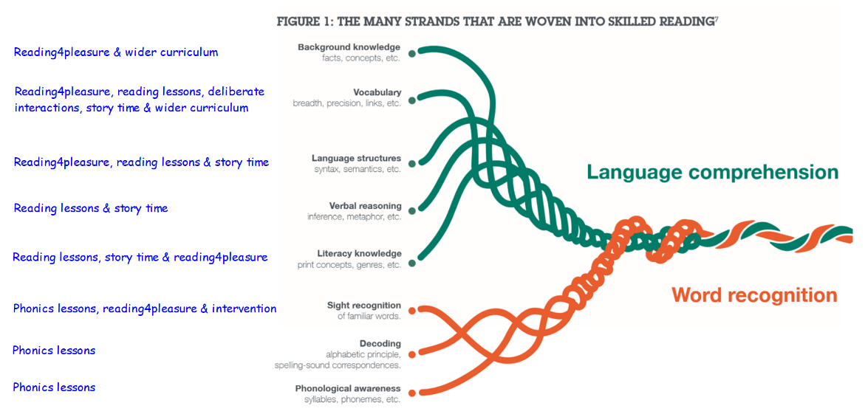

Implementation
At CINA, reading is at the heart of our curriculum. Children are exposed to variety of texts each half term within English lessons which link to the key themes and topics studied. This helps to support the teaching of specific vocabulary, provides additional opportunities for cross-curricular work, and offers the opportunities to explore a variety of genres and authors to influence writing.
Through reading, enjoying, using and analysing a range of text- types with children, we aim to offer greater breadth of experience, interest, knowledge and understanding of the purposes and features of different genre. Different text-types are studied within the context of other areas of the curriculum so the children can see purposeful reading in action.
Guided Reading
Our explicit reading sessions run each afternoon for 30 minutes in KS1. In KS1 they involve a structured 2 week timetable with one week whole-class reciprocal, shared reading and the second week being more skill based independent and carousel activities. In Early Years, children are introduced to the 6 VIPERS owls and are exposed to high quality discussions and questioning during each story-time. In Reception, children work together as a whole class during English Sessions and explore the texts with the teacher using VIPERS.

Teaching in Guided Reading sessions, across the school, focusses on developing pupils’ competence in both word reading and comprehension as outlined in the National Curriculum Programmes of Study for Reading. Skilled word reading involves both the speedy decoding of unfamiliar printed words and the speedy recognition of familiar printed words. Underpinning both is the understanding that the letters on the page represent the sounds in spoken words. This is why, at Carlyle Infant and Nursery Academy, phonics is emphasised in the early teaching of reading to secure independent decoding and we use the Letters and Sounds programme to achieve this.
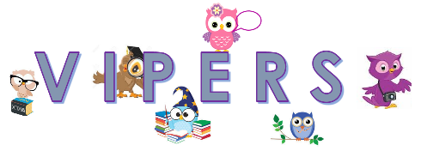
To ensure curriculum coverage, the national curriculum reading content domains have been organised under the acronym VIPERS. Children are introduced to the VIPER characters when they enter Nursery and continue to be exposed to their relevant skills throughout EYFS and KS1.

V | Vocabulary | draw on knowledge of vocabulary to understand texts  give / explain the meaning of words in context
I | Inference | make inferences from the text  make inferences from the text / explain and justify inferences with evidence from the text  make comparisons within the text
P | Prediction | predict what might happen on the basis of what has been read so far  predict what might happen from details stated and implied
E | Explanation | identify/explain how information / narrative content is related and contributes to meaning  identify / explain how meaning is enhanced through choice of words and phrases
R | Retrieval | identify / explain key aspects of fiction and non-fiction texts, such as characters, events, titles  retrieve and record information / identify key details from fiction and non-fiction
S | Sequencing | identify and explain the sequence of events in texts  summarise main ideas from more than one paragraph
*Phonics/word reading is not covered by the VIPERS acronym. Reference to Phonics Teaching & Learning Guide should be made for guidance on phonics teaching
EYFS
In EYFS, the Reading Curriculum is informed by the Literacy Development Matters statements. Topics are planned to cover a range of fiction and non-fiction books and to follow the children’s interests.
Reading is taught through the use of a range of books that introduce the skills of left to right orientation, turning the pages, discussing the pictures etc. Favourite books are repeated often and available for children to access in the provision. Staff, students and volunteers regularly read books to individual children or small groups to reinforce the skills of early reading and encourage enjoyment of books.

In EYFS, reading is an important feature inside and outside the classroom. We have a range of ways in which we promote reading:
- Book corners are stimulating and accessible, owned and loved by children, indoors and outdoors.
- Core books are used to plan for children’s interests and class topics.
- In Nursery, children take home a story book each week to share with parents. In the Summer Term children who are ready, take home a phonetically decodable book and reading record.
- In Reception, children read to an adult each week. Reading records communicate reading progress between home and school, and include teachers’ and parents’ feedback.
- Language rich environments provide opportunities for children to read labels through the use of Communication in Print (Widgits).
- Enthusiastic staff share their excitement of books with children.
- A range of quality books are available in all areas of the continuous provision.
- Opportunities for independent writing in all areas of the classroom.
- Using story props, story mapping, story sacks, role play areas and displays to enhance core books.
- Opportunities for children to learn from clearly modelled ‘reading behaviours’, for example, the recognition that print conveys meaning, the left to right directionality of English texts, the purpose of punctuation.
- Involving parents in understanding the importance of Early Literacy through parent workshops.
- Opportunities to retell and to act out stories using props and story maps.

KS1 - Year 1
A structured Guided Reading session will take place four times a week for 30 minutes straight after lunch. It follows a two-week cycle of whole class VIPERS shared reading and activities, followed by a week of more skill-based independent activities as a carousel. The remaining afternoon is dedicated to Handwriting.
An example is shown below:

 | Week 1 Whole Class Reading each lesson focussing on a different Viper | Week 2 Carousel Activity examples…
Lesson 1 - Monday | Prediction, Vocabulary, Inference,  Explanation, Sequencing | Teacher led- Inference  Independent Reading- Retrieval  Vocabulary activity from cloze  Sequencing story  Prediction from image from text
Lesson 2 - Tuesday
Lesson 3 - Wednesday
Lesson 4/Dictation - Thursday
Handwriting - Friday

KS1 – Year 2
Guided Reading is taught three times a week in year 2, with the two remaining afternoons dedicated to Handwriting and Dictation. Guided Reading lessons are taught following the same structure as Year one.

The learning intention each day should be informed by the Year 1/2 curriculum objectives relevant to the specific area of VIPERS being taught that day.
Progression in Reading

 | EYFS | Year 1 | Year 2
Decoding/ Fluency | Children use phonic knowledge to decode regular words and read them aloud accurately.  They read and understand simple sentences.  Children can say a sound for each letter of the alphabet and at least 10 diagraphs.  They read words consistent with their phonic knowledge by sound-blending.  Children can read aloud simple sentences and books that are consistent with their phonic knowledge, including common exception words. | Children read phonetically decodable texts confidently by blending the sounds and GPC that they have been taught so far – by the end of Year 1 they can read all 40 + phonemes.  They have a growing number of words they can read automatically including common suffixes, multi-syllabic words and contractions.  Children are beginning to read using appropriate expression. | Children can read accurately by blending, including alternative sounds for graphemes and multi-syllabic words containing these graphemes. They can read common suffixes and exception words, noting unusual correspondences.  Children demonstrate expression when reading aloud, particularly where characters are speaking in a story.
Range and familiarity of reading | Children listen to and discuss poems, stories and non-fiction at a level beyond that at which they can independently read.  They are encouraged to link what they hear or read to their own experiences  Children are becoming very familiar with key stories and traditional tales and can re-tell them through role-play. They can join in with well-known or repeated phrases in stories. | Children listen to and can discuss a wide range of poems, stories and non-fiction at a level beyond that at which they can independently read.  They are encouraged to link what they read or hear read to their own experiences  Children are becoming very familiar with key stories and traditional tales, retelling them and considering their particular characteristics.  They recognise and join in with predictable phrases. | Children listen to, discuss and express views about a wide range of poetry, stories and non-fiction at a level beyond that at which they can read independently.  Children are becoming increasingly familiar with and retelling a wider range of stories and traditional tales.  They recognise simple recurring literary language in stories and poetry.
Vocabulary | Children use talking about books to clarify their thinking, ideas and feelings.  E.g. linking to their own experiences. | Children discuss new word meanings and link them to words they already know. | Children begin to find the meaning of new words using the context of the sentence. They use pictures to help support this skill.
Inference | Children can infer meaning about characters’ feelings using pictures and verbally link these to their own experience. | Children make inferences about characters’ feelings using what they say and do to infer basic points with direct reference to the pictures and words in the text. | Children make inferences about characters’ feelings using what they say and do to infer basic points and begin, with support to pick up on more subtle references.
Prediction | Makes suggestions about what might happen next or how a story might end based on events so far.  Innovate stories through role-play and small world play. | Children make simple predictions based on the story and on their own life experience. They can begin to explain these ideas verbally or though pictures. | Children make predictions using their own knowledge as well as what has happened so far to make logical predictions and give explanations of them.
Explain | Children can begin to explain who their favourite character is and why. They can say whether or not they like a story and begin to explain why. | Children can say whether or not they like a story, who their favourite character is and explain why. They can begin to make links to their own experiences, other stories and characters. | Children explain their reasons for story and character preferences and make suggestions for improving a text. They can begin to make links to their own experiences, other stories and characters.
Retrieval | Children can answer simple recall questions about stories without pictures or prompts. | Children can answer questions about what has just happened in a story. | Children can explain their understanding of independent reading by answering simple questions about what they have just read. Children begin to learn the skill of ‘skim and scan’ to retrieve details.
Sequence/ Summarise | Children recall and order key events from the text. They use a story line or narrative in their role-play and small world play. | Children retell and order events from the text. They begin to discuss how events are linked. | Children retell and order events from the text. They begin to discuss how events are linked. They are able to focus on the main content of the story.

Questioning
During the whole class reading sessions, the teacher must use questioning to assess understanding.
When asking a question, teachers must have an awareness of the need for think time for students.
To allow for this teachers can
- Allow 7 seconds think time
- Use partner talk

Examples of progression in question stems

Vocab | What does the word ………. mean in this sentence?  Find and copy a word, which means ……….  What does this word or phrase tell you about ………?  Which word in this section do you think is the most important? Why?  Which of the words best describes the character/setting/mood etc?  Can you think of any other words the author could have used to describe this? | Explain | Who is your favourite character? Why?  Why do you think all the main characters are girls in this book?  Would you like to live in this setting? Why/why not?  Is there anything you would change about this story?  Do you like this text? What do you like about it?
Inference | Why was……. feeling……..?  Why did ………… happen?  Why did ………. say ……….?  Can you explain why……….?  What do you think the author intended when they said……….?  How does ………. make you feel? | Retrieval | What kind of text is this?  Who did…..?  Where did…..?  When did…..?  What happened when…..?  Why did …….. happen?
Prediction | Look at the book cover/blurb – what do you think this book will be about?  What do you think will happen next? What makes you think this?  How does the choice of character or setting affect what will happen next?  What is happening? What do you think happened before? What do you think will happen after?  What do you think the last paragraph suggests will happen next? | Sequence | Can you number these events 1-5 in the order that they happened?  What happened after …….?  What was the first thing that happened in the story?  Can you summarise in a sentence the opening/middle/end of the story?  In what order do these chapter headings come in the story?

Support & Challenge

Support
Children with SEND or who are well below ARE may struggle to access the text and in this scenario the following support should be offered
- Have child follow along with finger as they listen to another child reading the text.
- Use pictures to help understand key vocabulary.
- For each question, copy and paste the portion of text where the answer can be found below the question to help the child.
- Sit child next to a high attainer who can act as a lead learner
If a child is still unable to access the learning after these changes, referral should be made to the SENDCo to decide on the next steps. Sometimes a differentiated curriculum will be necessary.

Challenge
Children who have prior higher attainment need to be challenge in all lessons. Challenge should be given in the following ways
- Children to have access to independent reading
- Higher level questioning
- Alternative activities eg ‘Proving’, finding the mistakes and ‘What’s the question’ to develop deeper thinking
- Text extracts with higher tier vocabulary and more complex language to comprehend.

EAL
“Catch up” Phonics sessions as well as assessments are provided straight away for new EAL arrivals to assess their reading skills promptly and ensure new pupils are given the support required to succeed in reading. Staff liaise with parents to encourage them to enjoy bilingual books with their children, asking questions and discussing the book in their home language or in English, supporting their enjoyment of books and their acquisition of English.

Assessment

Key learning objectives for reading are identified from the National Curriculum (2014) and are translated into learning outcomes. Pupils’ progress is assessed during guided reading, supplemented by observations in shared reading and through individual assessments. Phonic assessments are carried out based on the developmental Letters and Sounds programme. Gaps in reading knowledge and skills are addressed through both Guided Reading and Shared/1:1 reading where specific skills can be targeted.

Assessment for learning is ongoing. The staff assess attainment in Reading every half term to update Target Tracker, using evaluations made on their planning and guided reading sessions, written assessments of comprehension and independent learning the children have produced – either written or verbal. Phonics progress is also assessed half termly. For formal testing within school see the assessment policy.

How do children catch up in reading?
Encouraged to read for pleasure
Learning broken up into smaller chunks
Being exposed to high quality discussions about texts
Teaching and learning of tier 2 words
Additional 1:1 reading sessions
Parental engagement encouraged
Additional phonics sessions

Reading for Pleasure

The importance of reading for pleasure has been paramount given the implications of the research by Teresa Cremin on behalf of the Open University. The implications of this research are at the beating heart of everything we do at CINA. There are a number of elements to our strategy to improve reading 4 pleasure.

Story Time
For the final 15 minutes of the day, children must have a story time. This should be the teacher reading a text in an engaging way. The teacher should take opportunities to talk about vocabulary and ask questions during these sessions. These sessions are a great chance to read texts that engage our most reluctant readers and ‘hook’ children onto the pleasure of reading.

Reading assemblies
Each week, the children are part of reading assembly run by the Principal and other staff members. It’s an opportunity to listen to other adults reading and enjoying a book together with peers as a whole school.

Library visits
At least once a year, children will be given the opportunity to visit the local library. Parents will be encouraged to join the local library.

School Library sessions
Children all have a weekly slot in our new library pod! They will come to the library to enjoy reading, take part in specific interventions, take a new book home and discuss authors and genres. The library has been carefully designed to entice and inspire children.

RAS newsletter
Each month, within the Principal newsletter, a Read Achieve Succeed newsletter is included. This celebrates the reading and book-related activities that happen across the Academy, and has a ‘Book of the Month’ review by children and staff.

Home Reading
We strongly encourage all pupils to read at home.
Whilst pupils are learning to apply their phonic knowledge, they will have a phonetically decodable book to read at home. This will either be a Dandelion Reader or an Oxford Reading Tree. In addition, they will have a book to share with a family member to take home from the library.

The Reading Environment
Every class will have access to an attractive and interesting reading area that invites children to come and read a variety of fiction and non-fiction texts reflecting genres, cultures, gender and race. Every class will have a range of books available to pupils that reflect their current class topic, and the interests of the children. ICT in the classroom through laptops, iPads and interactive whiteboards will be available for children to access digitally written materials to support their learning in all curriculum areas. A respect for books will be fostered and modelled by all staff.

Online Reading
Each child at CINA has access to MyOn- an online library of books. Teachers will match books to topics and children will also have the freedom to explore online reading of their own choice both in-school and at home.

Appendix
- English LTP with Text focus
- Example Guided Reading planning
- Reading Levels and book band alignment
- Parent Reading Booklet

Appendix 1- English LTP with text focus
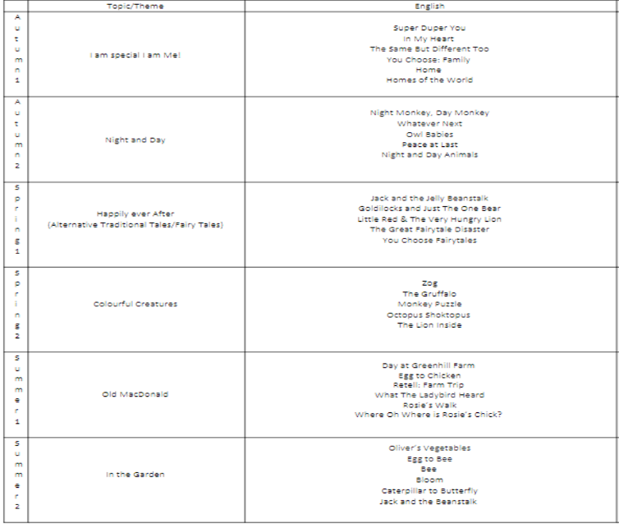
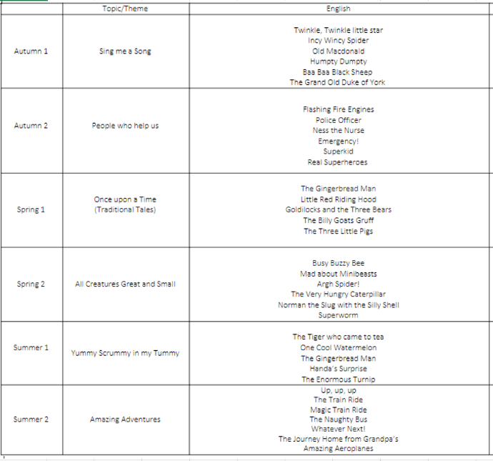
Nursery Reception
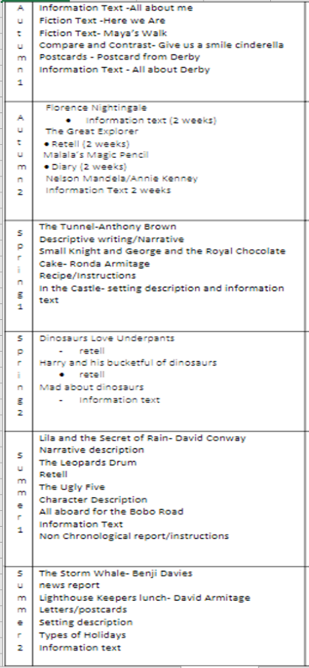
Year 1 Year 2
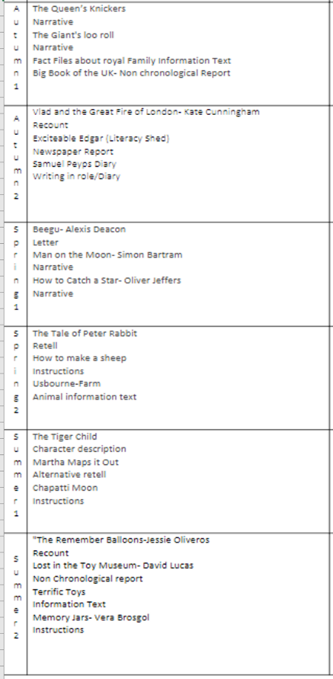

Appendix 2- Example guided Reading planning
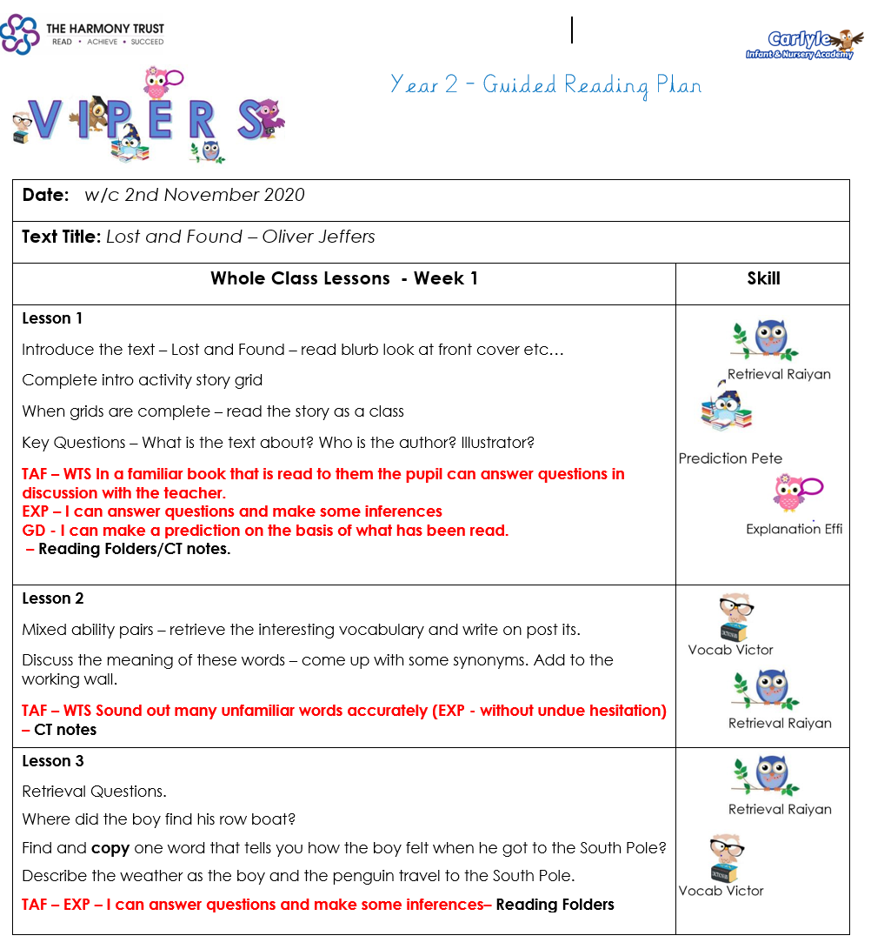

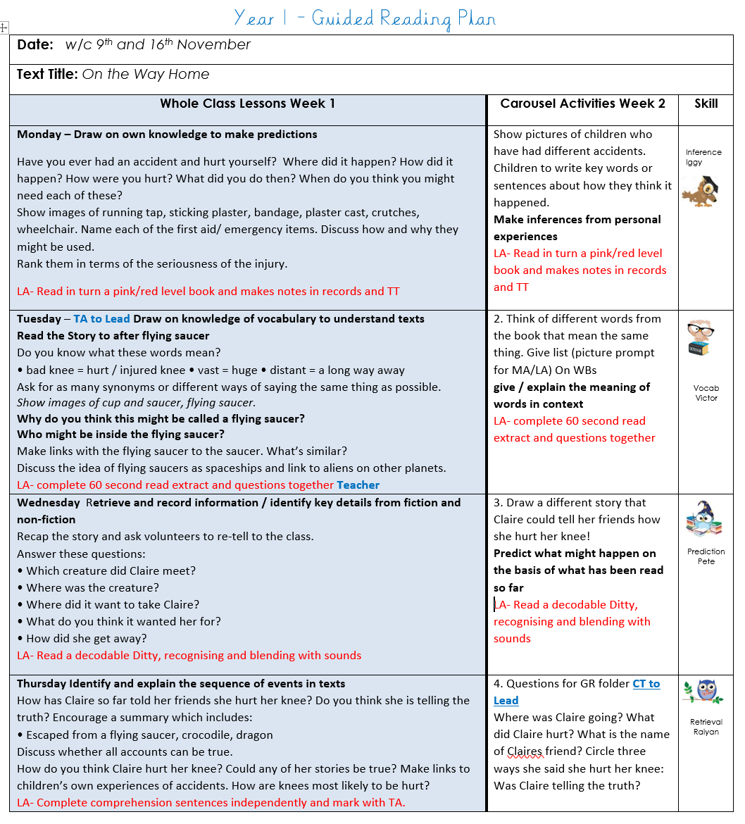

Appendix 3- Reading levels book band alignment

Books from Dandelion Readers and ORT aligned to phases from Letters and sounds.

Book Band guide for parents
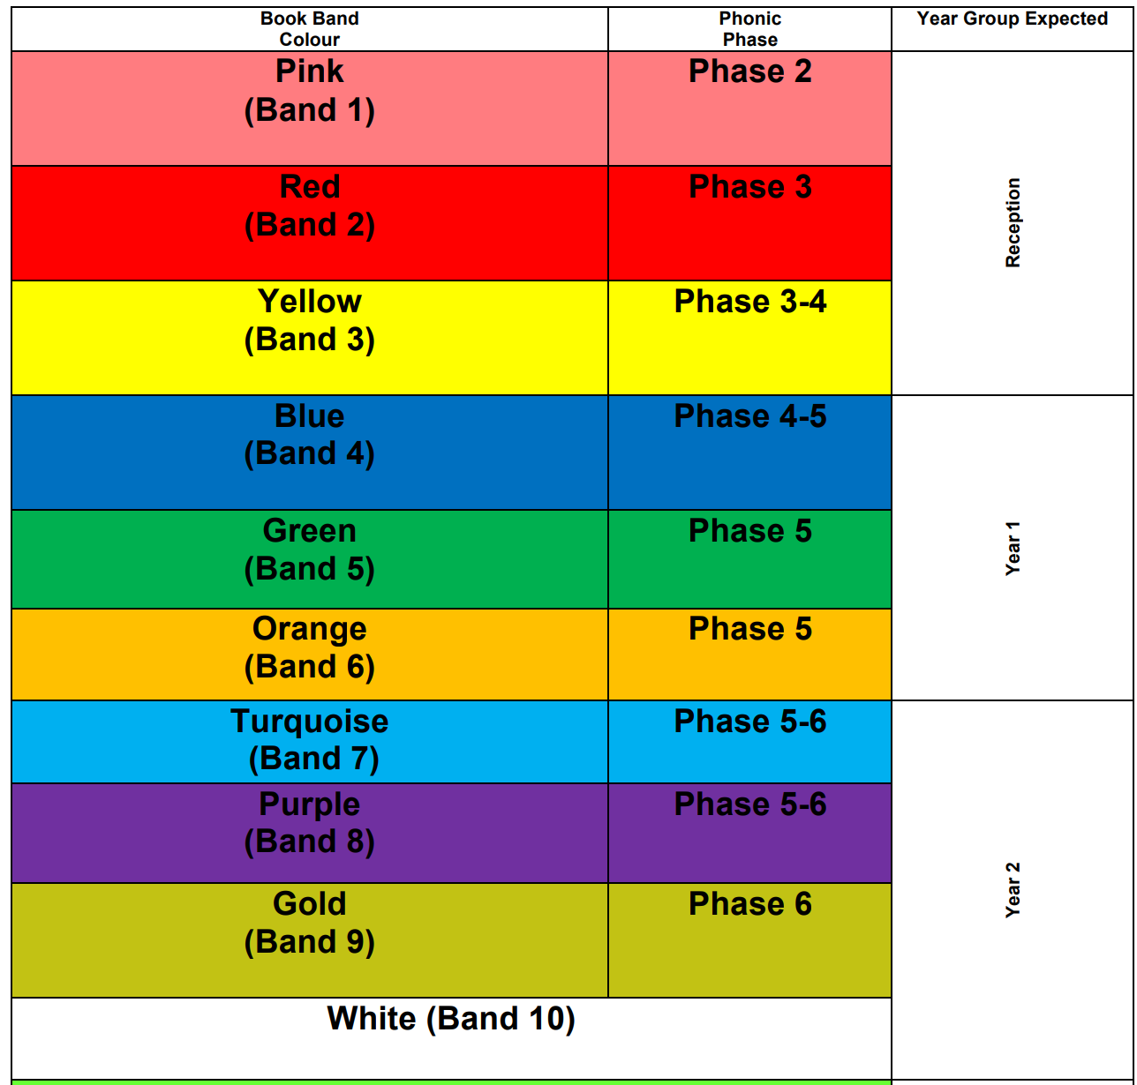
Expected progression through book bands (ARE)

Appendix 4- Parent Reading Booklet

Reading booklet for Parents can also be found on our website:

https://www.carlyle.theharmonytrust.org/page/read-achieve-succeed

